**EXPERIMENT – 2,3**

**TITLE: Basic Java Programming**

**1. Write a program to find the largest of 3 numbers.**

class large{

public static void main(String args[]){

int a,b,c;

a=Integer.parseInt(args[0]);

b=Integer.parseInt(args[1]);

c=Integer.parseInt(args[2]);

if(a>b&&a>c){

System.out.println("greatest number is " + a);

}

else if(b>a&&b>c){

System.out.println("greatest number is " + b);

}

else{

System.out.println("greatest number is " + c);

}

}

}

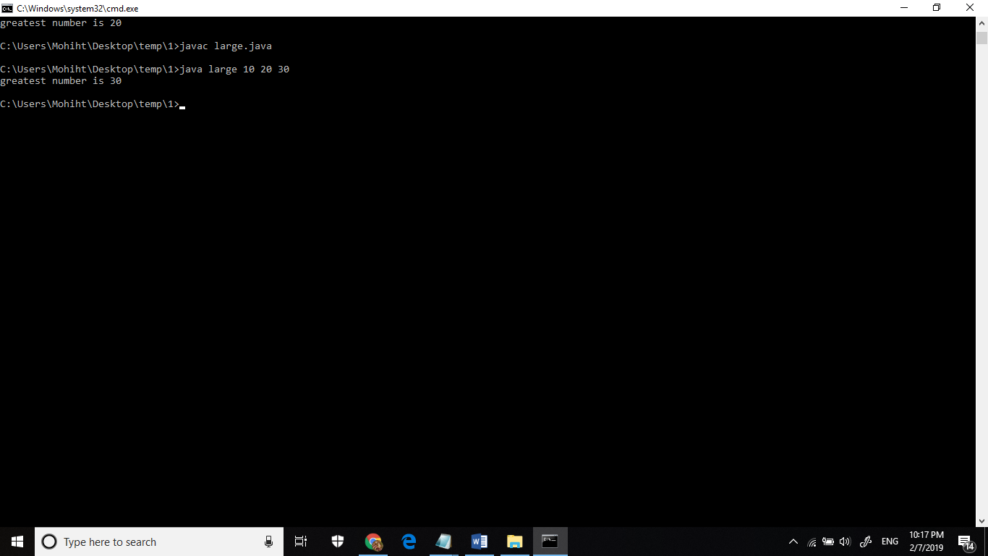

**2.Write a program to add two number using command line arguments.**

class add

{

public static void main(String ar[])

{

int x,y,s;

x=Integer.parseInt(ar[0]);

y=Integer.parseInt(ar[1]);

s=x+y;

System.out.println("sum of " + x + " and " + y +" is " +s);

}

}

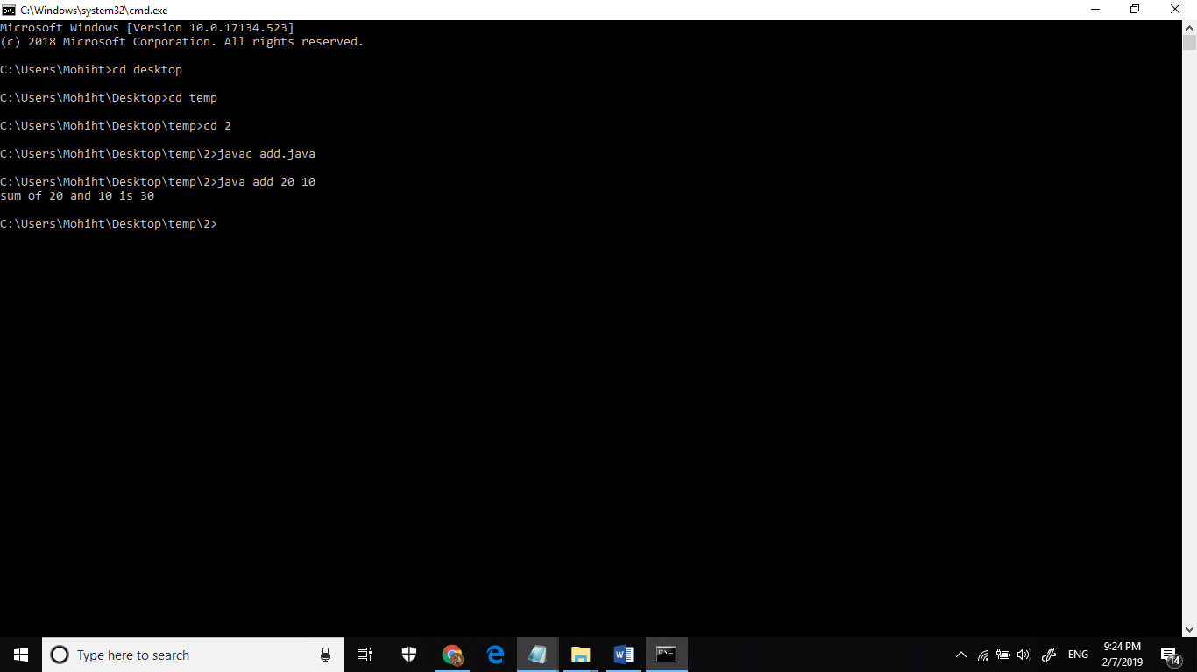

**3) Write a program to print Fibonacci series using loop.** **import java.util.Scanner;**

class fib{

public static void main(String agrs[]){

Scanner sc = new Scanner(System.in);

int num ,i,n1=0,n2=1,n3;

System.out.println("enter a number uptil you want fibonacci series");

num=sc.nextInt();

System.out.print(n1+" "+n2);

for(i=2;i<num;++i)

{

n3=n1+n2;

System.out.print(" "+n3);

n1=n2;

n2=n3;

}

}

}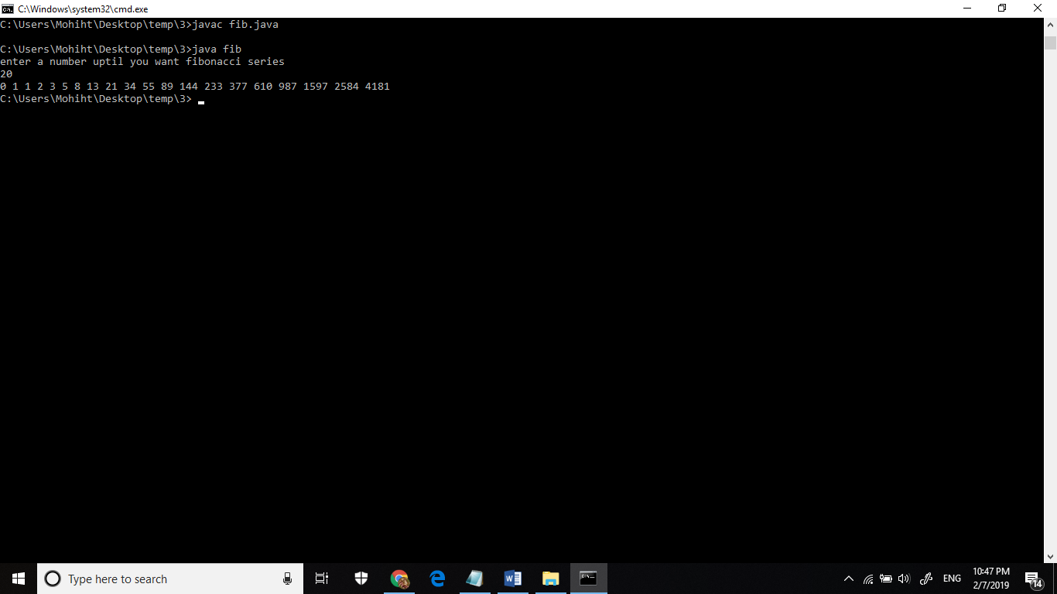

**4. Write a program to implement a command line calculator.**

import java.util.Scanner;

class calc{

public static void main(String args[]){

int a , b ,op, result=0;

Scanner sc= new Scanner(System.in);

System.out.println("enter operant 1");

a=sc.nextInt();

System.out.println("enter operant 2");

b=sc.nextInt();

System.out.println("choose operator 1. add 2. sub 3. multiply 4. divide");

op=sc.nextInt();

switch(op){

case 1:

result=a+b;

break;

case 2:

result=a-b;

break;

case 3:

result=a*b;

break;

case 4:

result=a/b;

break;

default:

System.out.println("error");

}

System.out.println(result);

}

}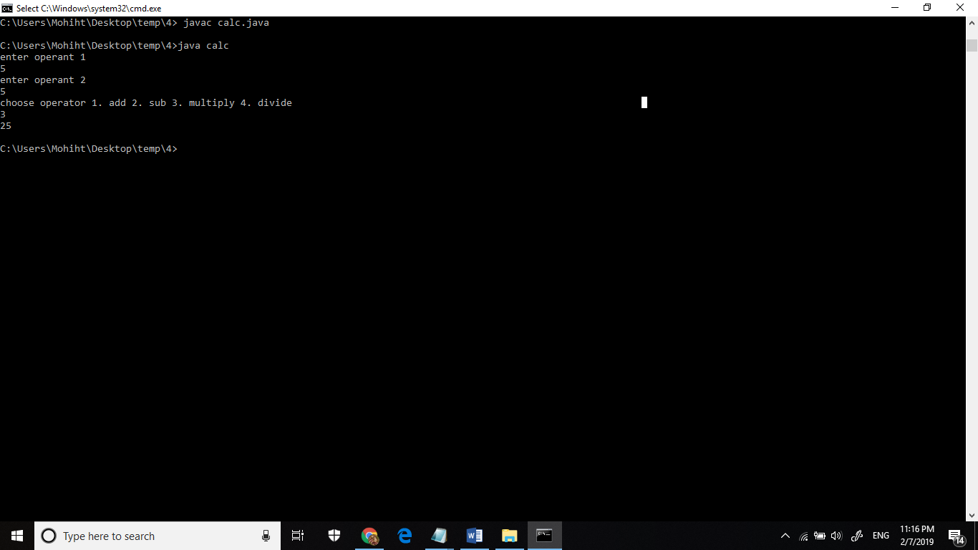

**5.Write a program using classes and object in java.**

class demo{

int a= 10;

void show(){

System.out.println(a);

}

public static void main(String args[]){

demo d1 = new demo();

d1.show();

}

}

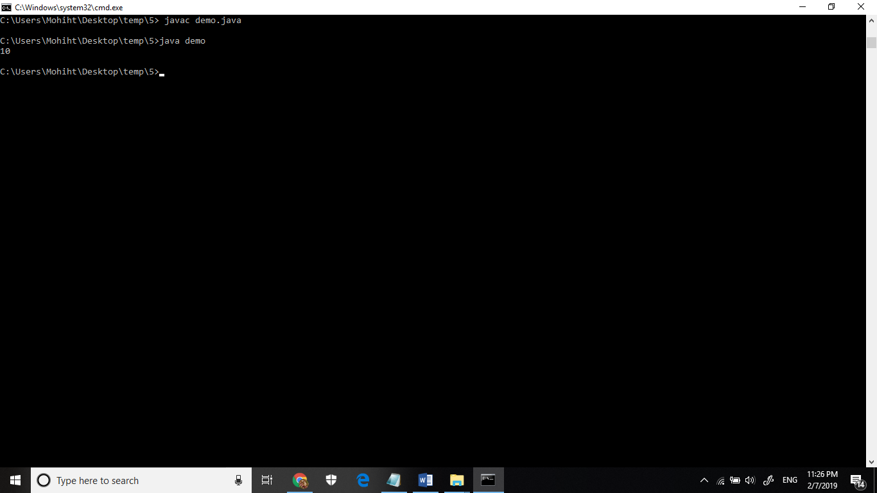

**6.Write a program to accept 10 student’s marks in an array, arrange it into ascending order, convert into the following grades and print marks and grades in the tabular form.**

**Between 40 and 50 : PASS**

**Between 51 and 75 : MERIT**

**and above : DISTINCTION**

import java.util.*;

class result{

public static void main(String args[]){

System.out.println("enter 10 student marks" );

Scanner s=new Scanner(System.in);

int arr[];

arr=new int[10];

int i;

for(i=0;i<10;i++)

{

arr[i]=s.nextInt();

}

System.out.println("grades are:-" );

for(i=0;i<10;i++){

if(arr[i]>40&&arr[i]<50){

System.out.println(arr[i] + "\t"+"PASS" );

}

else if(arr[i]>51&&arr[i]<75){

System.out.println(arr[i] + "\t"+"MERIT" );

}

else if(arr[i]>75){

System.out.println(arr[i] + "\t"+"DISTINCTION" );

}

else{

System.out.println(arr[i] + "\t"+"FAIL" );

}

}

}

}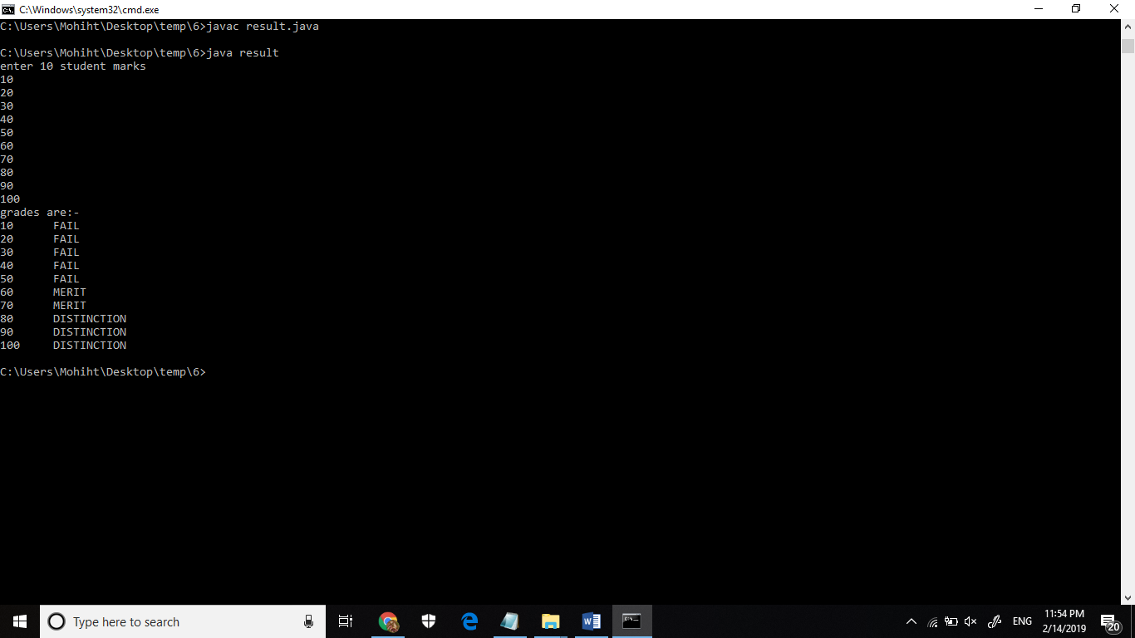

**7. Write a program to accept three digits (i.e. 0 - 9) and print all its possible combinations.**

**(For example if the three digits are 1, 2, 3 than all possible combinations are : 123,132,**

**213, 231, 312, 321.)**

public class combination{

public static void main(String[] args) {

int[] input = { 1, 4, 3 };

for (int x = 0; x < 3; x++) {

for (int y = 0; y < 3; y++) {

for (int z = 0; z < 3; z++) {

if (x != y && y != z && z != x) {

System.out.println(input[x] + "" + input[y] + ""

+ input[z]);

}

}

}

}

}

}

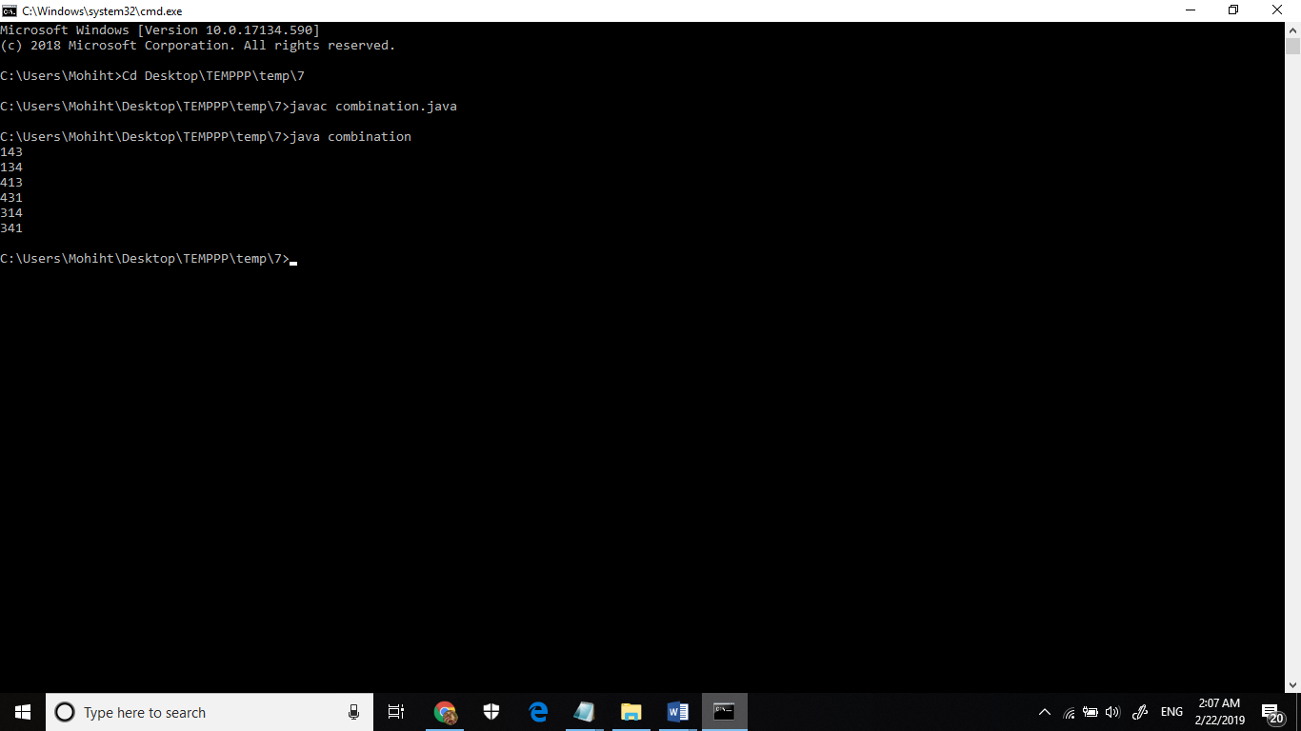

**8. Write a Java Program to accept 10 numbers in an array and compute the square of each number. Print the sum of these numbers.**

import java.util.Scanner;

public class arr

{

public static void main(String[] args)

{

int n, sum = 0;

Scanner s = new Scanner(System.in);

System.out.print("Enter no. of elements you want in array:");

n = s.nextInt();

int a[] = new int[n];

System.out.println("Enter the elements:");

for(int i = 0; i < n; i++)

{

a[i] = s.nextInt();

sum = sum + a[i]*a[i]*a[i];

}

System.out.println("Sum:"+sum);

}

}

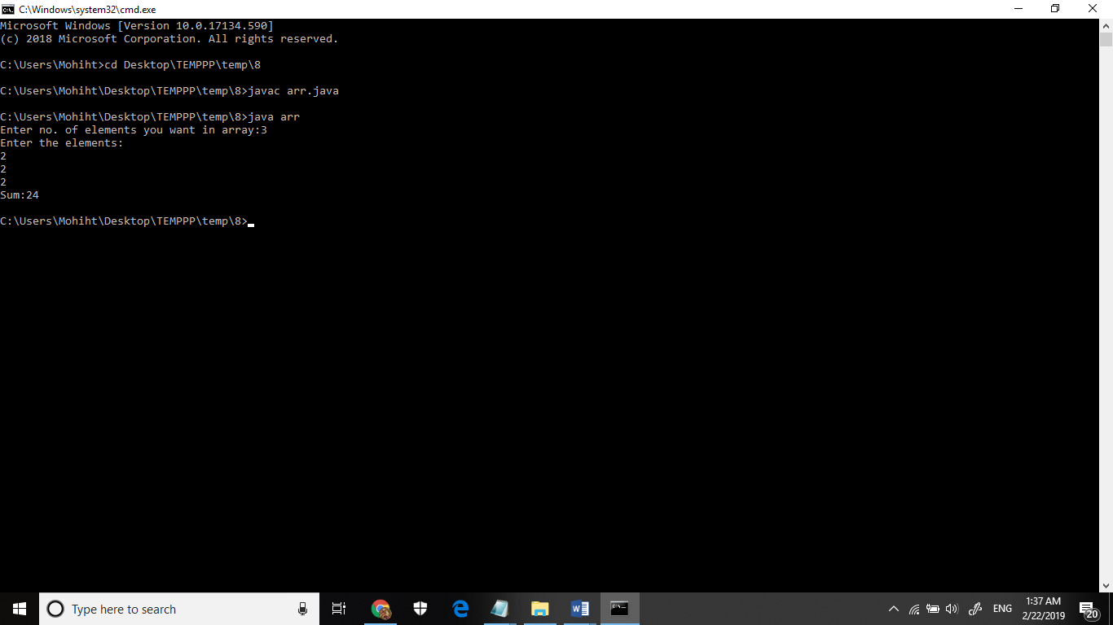

**9. Write a program to input a number of a month (1 - 12) and print its equivalent name of**

**the month.( e.g 1 to Jan, 2 to Feb. 12 to Dec.)**

class month{

public static void main(String args[]){

Scanner sc= new Scanner(System.in);

System.out.println("enter the number of month");

int m=sc.nextInt();

switch(m){

case 1:

System.out.println("January");

break;

case 2:

System.out.println("Febuary");

break;

case 3:

System.out.println("March");

break;

case 4:

System.out.println("April");

break;

case 5:

System.out.println("May");

break;

case 6:

System.out.println("June");

break;

case 7:

System.out.println("July");

break;

case 8:

System.out.println("August");

break;

case 9:

System.out.println("September");

break;

case 10:

System.out.println("October");

break;

case 11:

System.out.println("November");

break;

case 12:

System.out.println("December");

break;

default:

System.out.println("incorrect input");

}

}

**}**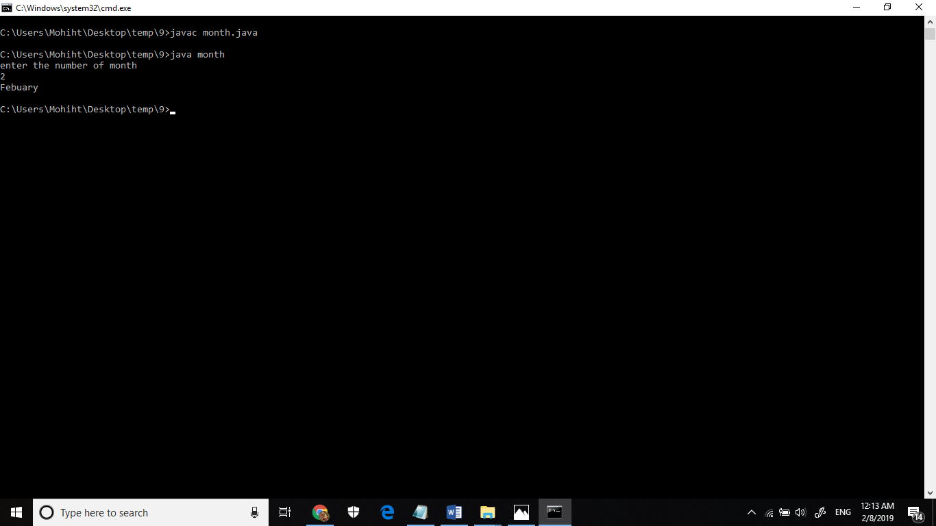

**10. Write a program to find the sum of all integers greater than 40 and less than 250 that are divisible by 5.**

**class chk {**

public static void main(String[] args){

int num;

for(num=41;num<250;num++){

if(num%5==0){

System.out.println(num);

}

}

}

}

